TSS Cross Country Map 2026: Bicentennial Park
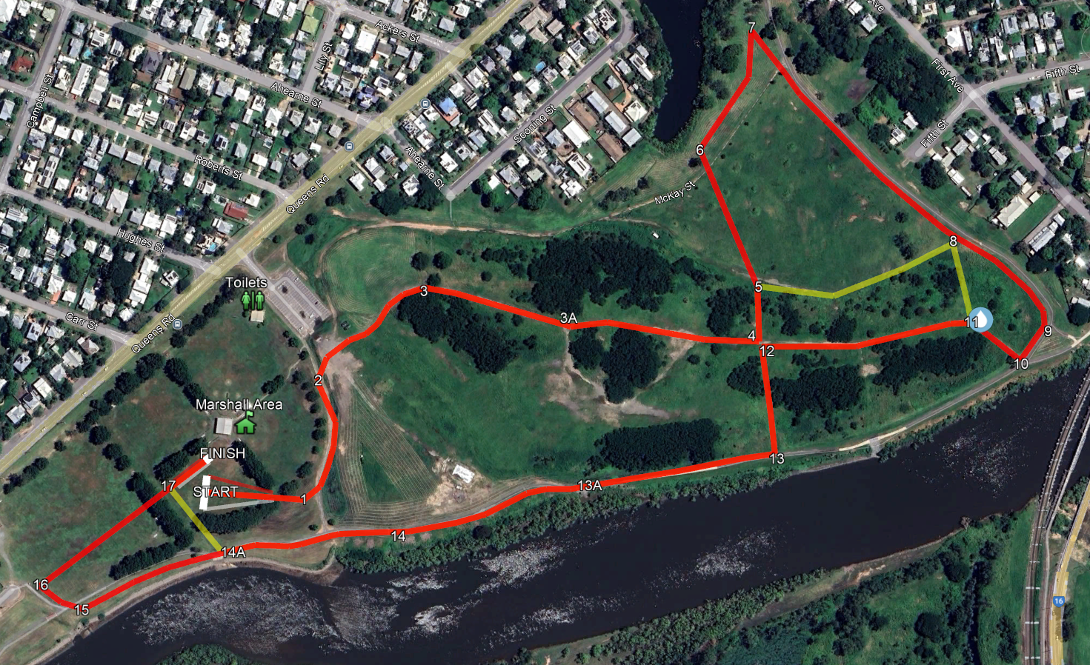
2km course (2 x shorter loops)
3km course

TSS Cross Country: Checkpoint Supervisor Positions
At each checkpoint there shall be a post or a numbered cone with that number printed clearly on it.
White markers on right, red markers on left.

POST # | Person on POST is to direct all students:
*1 | Runners to merge and turn left, run between markers
*2 | Runners cross bike path, run between markers and up hill on gravel path
*3 | Halfway up hill on gravel track, line of sight to 2
*3A | Top of hill on gravel path
*4 | Direct runners turn left then downhill to 5
*5 | 2km runners turn right towards 8 (follow yellow markers), 3 km veer left towards the creek, follow white & red markers
6 | Post Near Creek: Run parallel to creek, follow markers to 7
7 | Post 7, turn right and follow the markers next to path towards 8
8 | 2km runners coming from 5 turn right up hill. 3km runners coming from 7 go straight towards 9
*9 | 3km runners follow markers to 10
*10 | Turn right up the hill
*11 | Water Stop (2km runners from 8 / 3km runners from 10) follow markers to 12
*12 | Left turn down the hill towards the river
*13 | Bottom of hill, runners turn right cross bike-path to river side, follow markers to bridge.
*13A | Bridge, runners run on bridge, then follow markers riverside of path
14 | Follow markers, white on your right
*14A | 2km runners turn right and follow yellow markers to finish line. 3km runners continue straight towards 15
15 | Right turn, follow markers towards 16
16 | Right turn and run towards the line of trees (Post 17)
17 | All runners who are finishing are to be directed straight ahead to the finish.
*Temporary Cones

